**MODEL INSTITUTE OF ENGINEERING & TECHNOLOGY (AUTONOMOUS)**

**(Permanently Affiliated to the University of Jammu, Accredited by NAAC with “A” Grade)**

Minor project report| Computer Network

“Configuration of Network devices using Static and Default Routing”



Submitted By:

Group-5

Sahil Kumar (2020a1r180)

Rikit Gupta (2020a1r176)

Arya Dev Singh(2020a1r195)

Rishi Mehra(2020a1r175)

**SUBMITTED To**

**Department of Computer Science**

**And Engineering**

**Model Institute of Engineering and Technology (Autonomous)**

**Jammu, India**

CONTENTS

|  |  |
| --- | --- |
| S.NO. | Topics |
| 1. | Introduction |
| 2. | Static Routing |
| 3. | Advantages of static routing |
| 4. | Disadvantages of static routing |
| 5. | Default Routing |
| 6. | Advantages of default routing |
| 7. | Disadvantage of default routing |
| 8. | Configuration of static routing |
| 9. | Configuration of default routing |
| 10. | Project info |
| 11. | Snapshot of project |
| 12. | Summary |
| 13. | References |

Introduction

A static route is a route that is created manually by a network administrator. Static routes are typically used in smaller networks. In static routing, the Router's routing table entries are populated manually by a network administrator.The opposite of a static route is a dynamic route. In dynamic routing, the the routing table entries are populated with the help of routing protocols.

Default Routing is used while networks address a single go-out point. It is also useful while the bulk of transmission networks need to transmit the information to the equal hop device.

STATIC ROUTING

“It is a type of fixed routing in which path selection and routing is controlled manually by a network admin”. Static routes have Admin Distance (AD) of 1. Path selection  and routing is manually controlled by a network administrator in static routing. Static routes are always preferred over Dynamic routing protocols like OSPF/RIP/BGP. They consume less resources and less bandwidth intensive. Static Routes are not fault tolerant (paths are always fixed). Therefore, they are not practical for large networks.

Types of Static Route

There are 3 types of Static routes:

1. Standard Static Route: Normal static routes used when connecting to a specific remote network
2. Default Static Route: A static route with 0.0.0.0/0 as the destination IP address (a route that matches all packets and also referred to as default gateway)
3. Other types: Summary Static Route, Floating Static Route (Backup routes)

Advantages of Static Routing

There are many advantages of Static Routing and some of them are listed below:

* Consumes less resources and bandwidth intensive (there is no overhead in terms of CPU usage of router)
* Has a Small Routing Table
* It is more secure because these are not advertised over the network
* Admin has more control (choice of best path selection)
* Does not require any advance knowledge or skills from the Admin

Disadvantages of Static Routing

Below are some of the disadvantages associated with Static routing:

* It is impractical on large networks
* The administrator needs to know the entire network
* Not a scalable option (Every change needs to be manually configured on each router in the internetwork)
* Has no fault tolerance
* Does not support load balancing

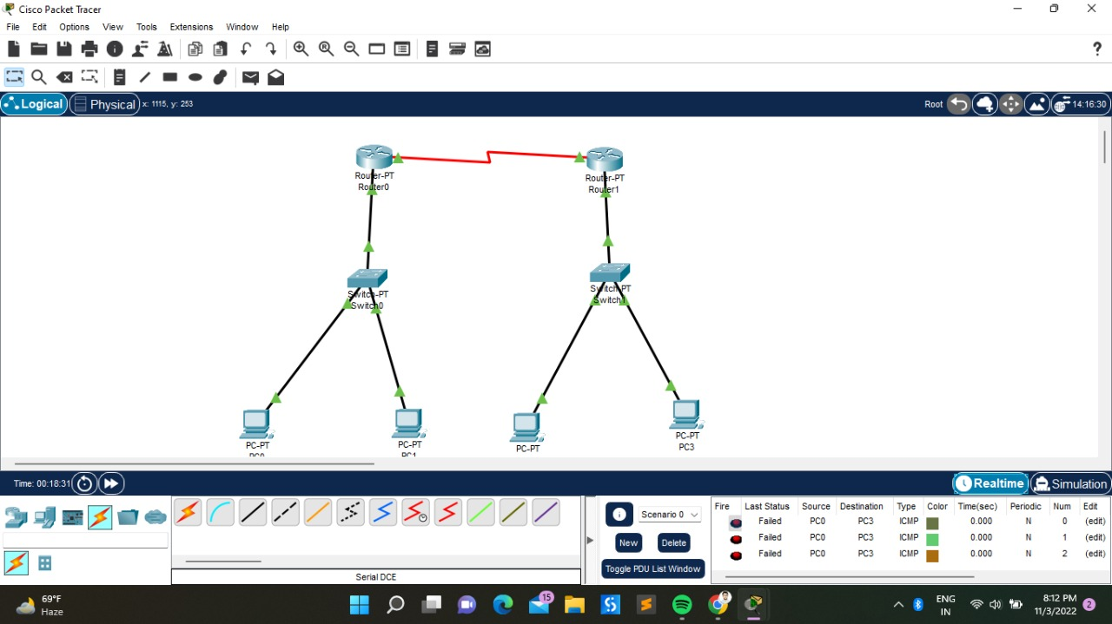

Static Routing

DEFAULT ROUTING

“Default Routing is a type of routing that sends all IP requests to a single, fixed Default Gateway”. Default Routing has an Admin Distance (AD) 255 (lowest priority in Routing table). They are represented by 0.0.0.0/0 for ipV4 & ::/0 in IPv6. Default routes handle traffic for unknown destinations and all IP requests are sent to a single fixed Default Gateway. Default routes are not fault tolerant therefore, they are impractical for large networks. They are less resource and Bandwidth intensive. Default routing is useful when dealing with a network with a single point of exit.

Advantages of Default Routing

The following are the advantages of Default routing:

* It is less resource intensive (there is no overhead in terms of CPU usage of router)
* It is less bandwidth intensive between routers
* Has a Small Routing Table
* Allows connectivity to remote networks even if they are not in the routing table at all
* Effective when a bulk of destination networks have to be routed to a single next-hop device
* Does not require any advanced knowledge or skills by the Admin

Disadvantages of Default Routing

The following are the disadvantages of Default routing:

* Has no fault tolerance (if the link to Default Gateway fails, it is not auto routed to available ports)
* It is impractical on large networks
* Does not support load balancing

Configuration of static Routing

R1 having IP address 172.16.10.6/30 on s0/0/1, 192.168.10.1/24 on fa0/0.   
R2 having IP address 172.16.10.2/30 on s0/0/0, 192.168.20.1/24 on fa0/0.   
R3 having IP address 172.16.10.5/30 on s0/1, 172.16.10.1/30 on s0/0, 10.10.10.1/24 on fa0/0.

Now configuring static routes for router R3:

R3(config)#ip route 192.168.10.0 255.255.255.0 172.16.10.2

R3(config)#ip route 192.168.20.0 255.255.255.0 172.16.10.6

Here, provided the route for 192.168.10.0 network where 192.168.10.0 is its network I’d and 172.16.10.2 and 1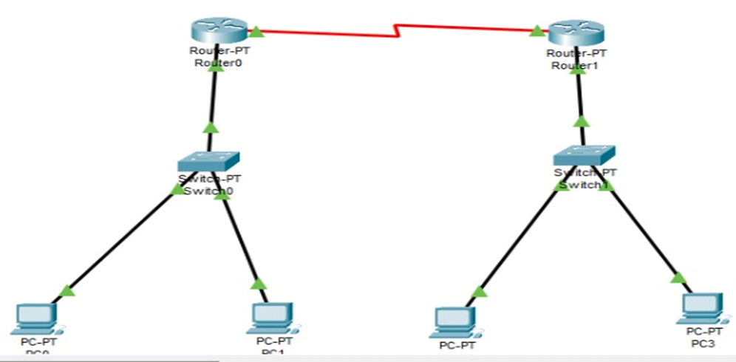72.16.10.6 are the next-hop address.

Now, configuring for R2:

R2(config)#ip route 192.168.20.0 255.255.255.0 172.16.10.1

R2(config)#ip route 10.10.10.0 255.255.255.0 172.16.10.1

R2(config)#ip route 172.16.10.0 255.255.255.0 172.16.10.1

Similarly for R1:

R1(config)#ip route 192.168.10.0 255.255.255.0 172.16.10.5

R1(config)#ip route 10.10.10.0 255.255.255.0 172.16.10.5

R1(config)#ip route 172.16.10.0 255.255.255.0 172.16.10.5

**Configuration of default routing**Using the same topology which we have used for the static routing before.

In this topology, R1 and R2 are stub routers so we can configure default routing for both these routers.

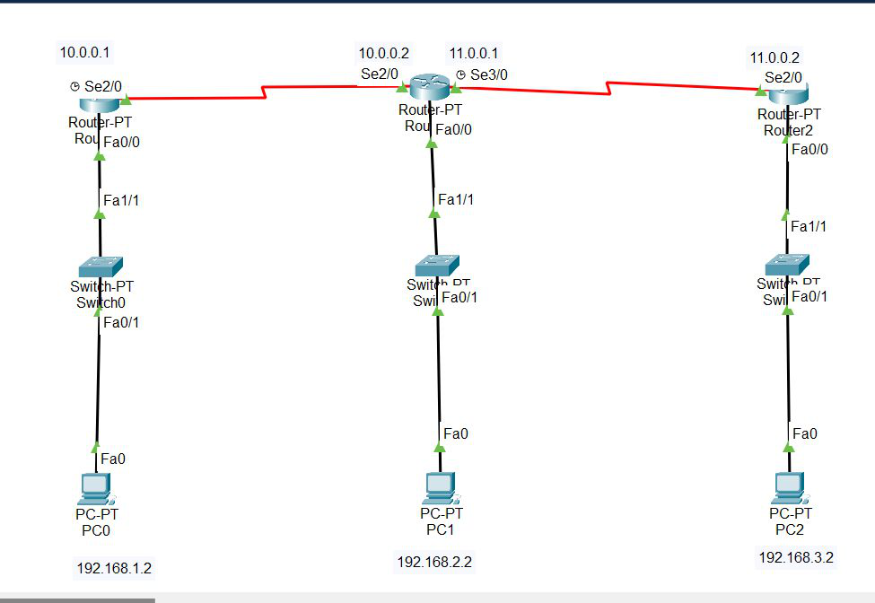

Configuring default routing for R1:

R1(config)#ip route 0.0.0.0 0.0.0.0 172.16.10.5

Now configuring default routing for R2:

R2(config)#ip route 0.0.0.0 0.0.0.0 172.16.10.1

Project info

Static routing

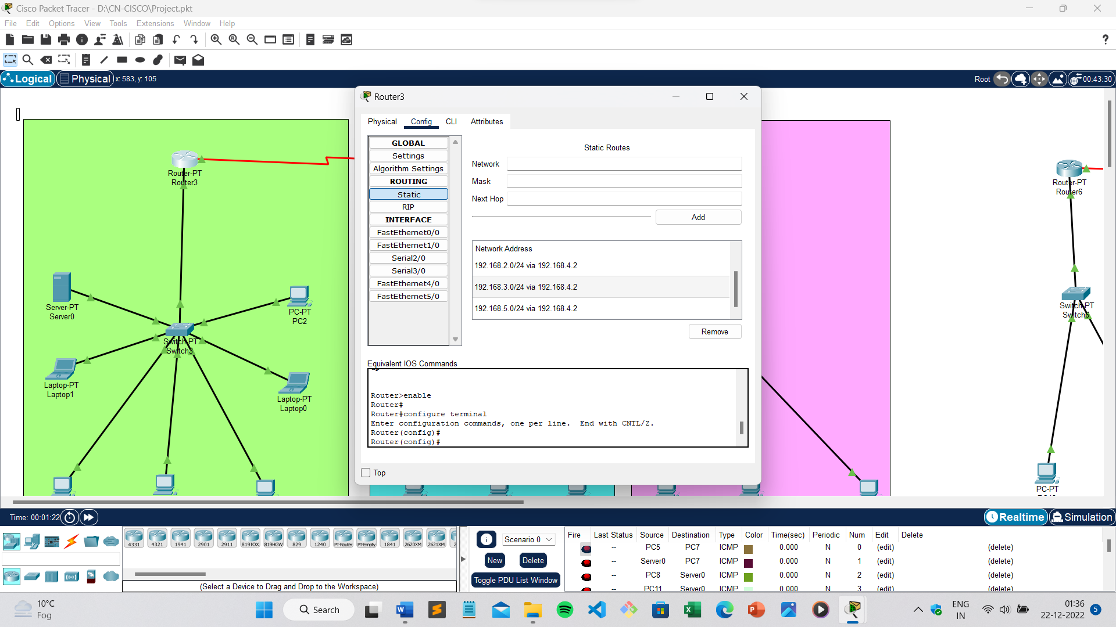

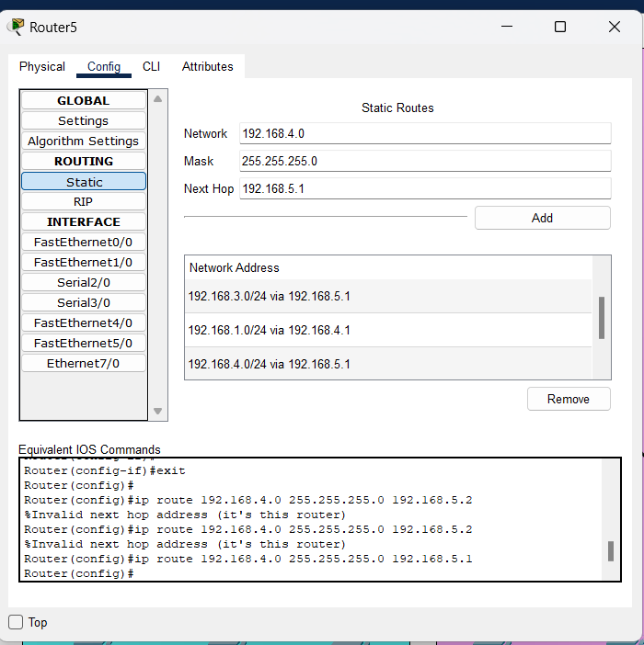 Config the static routing for Next node in router3

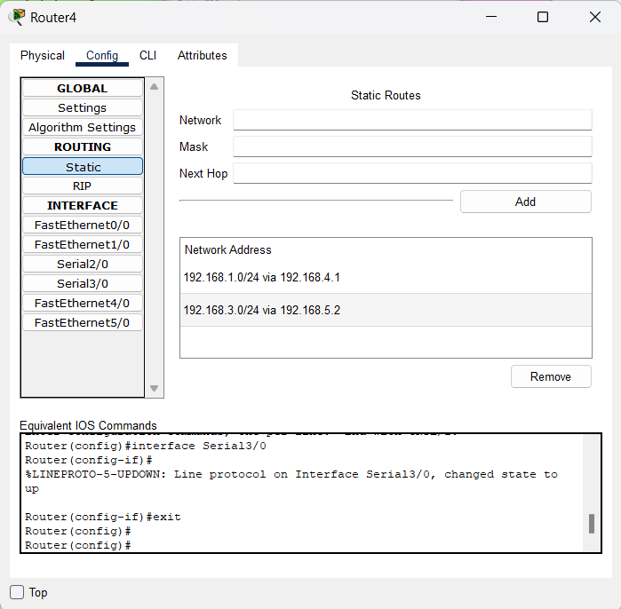  
 Config the static routing for Next node in router4

Default routing

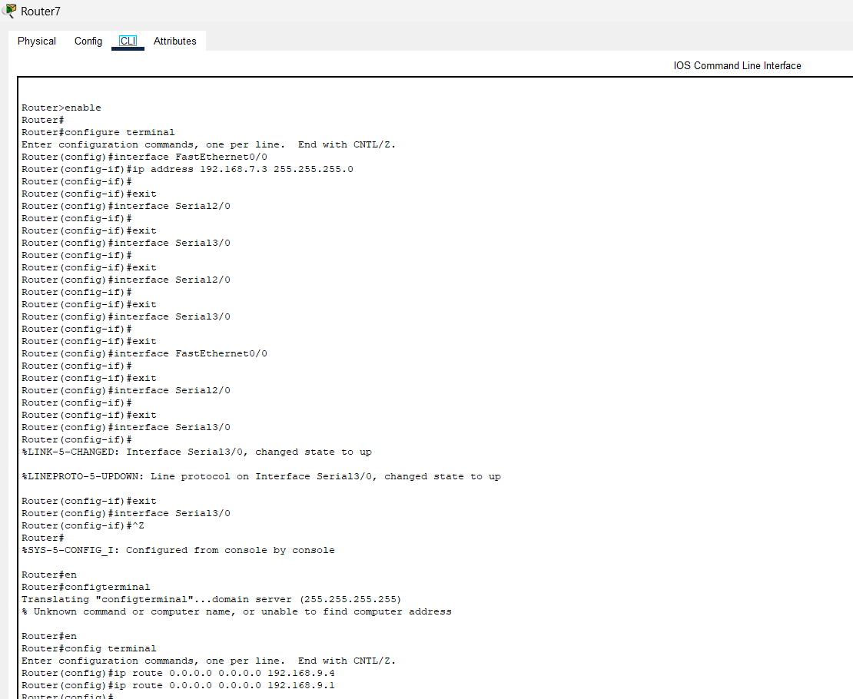

Default routing configuration

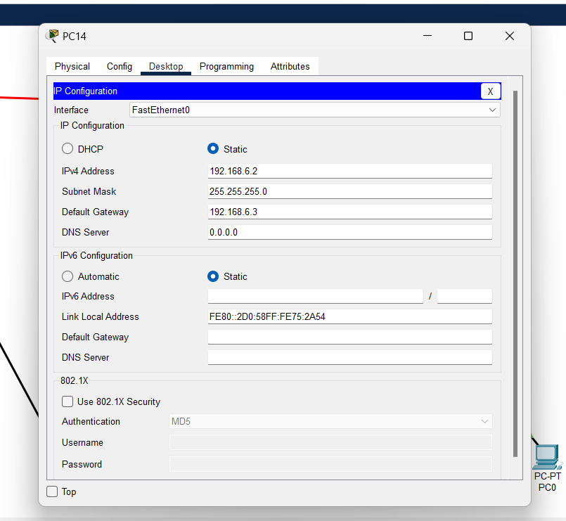

Screenshot of project

Static routing

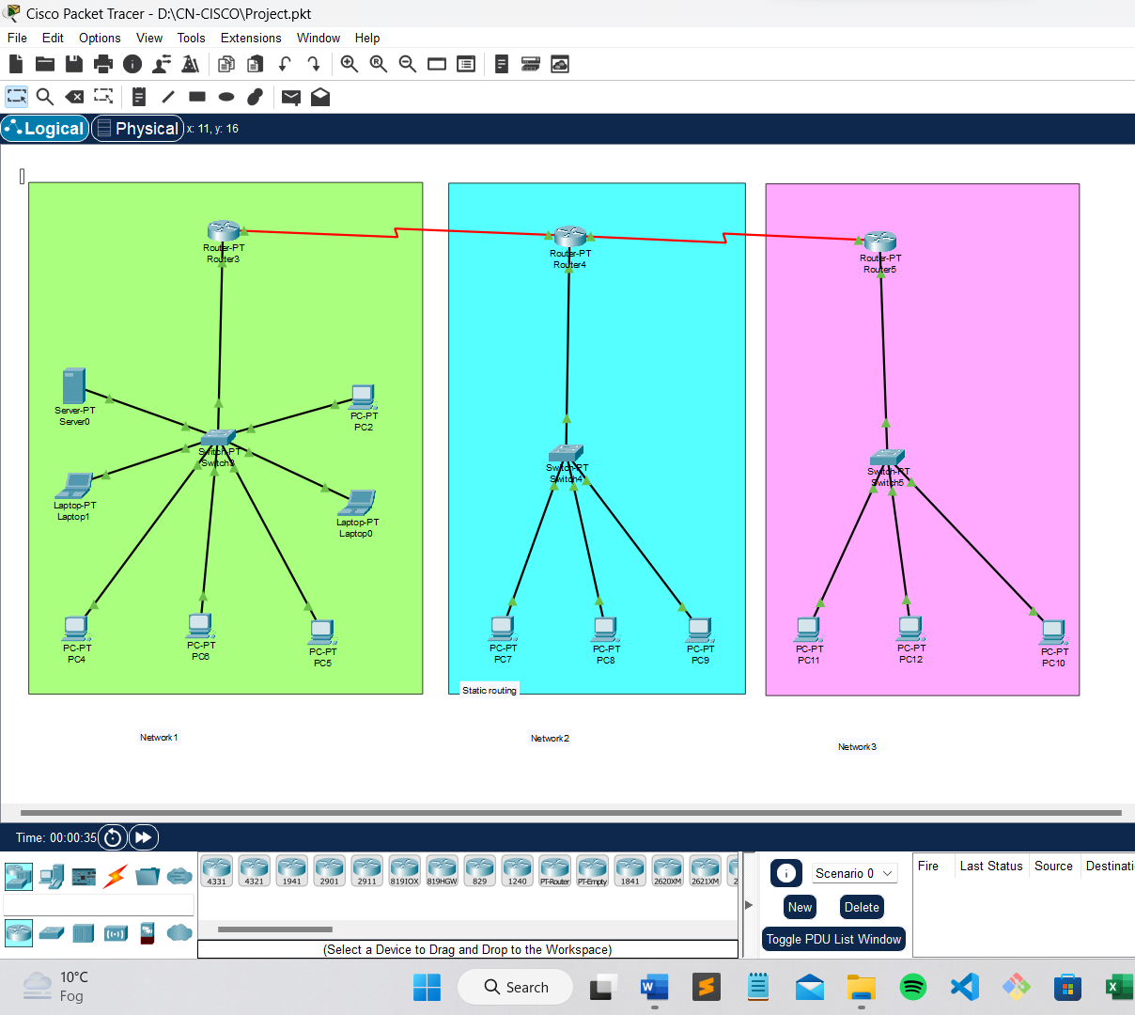

Default routing

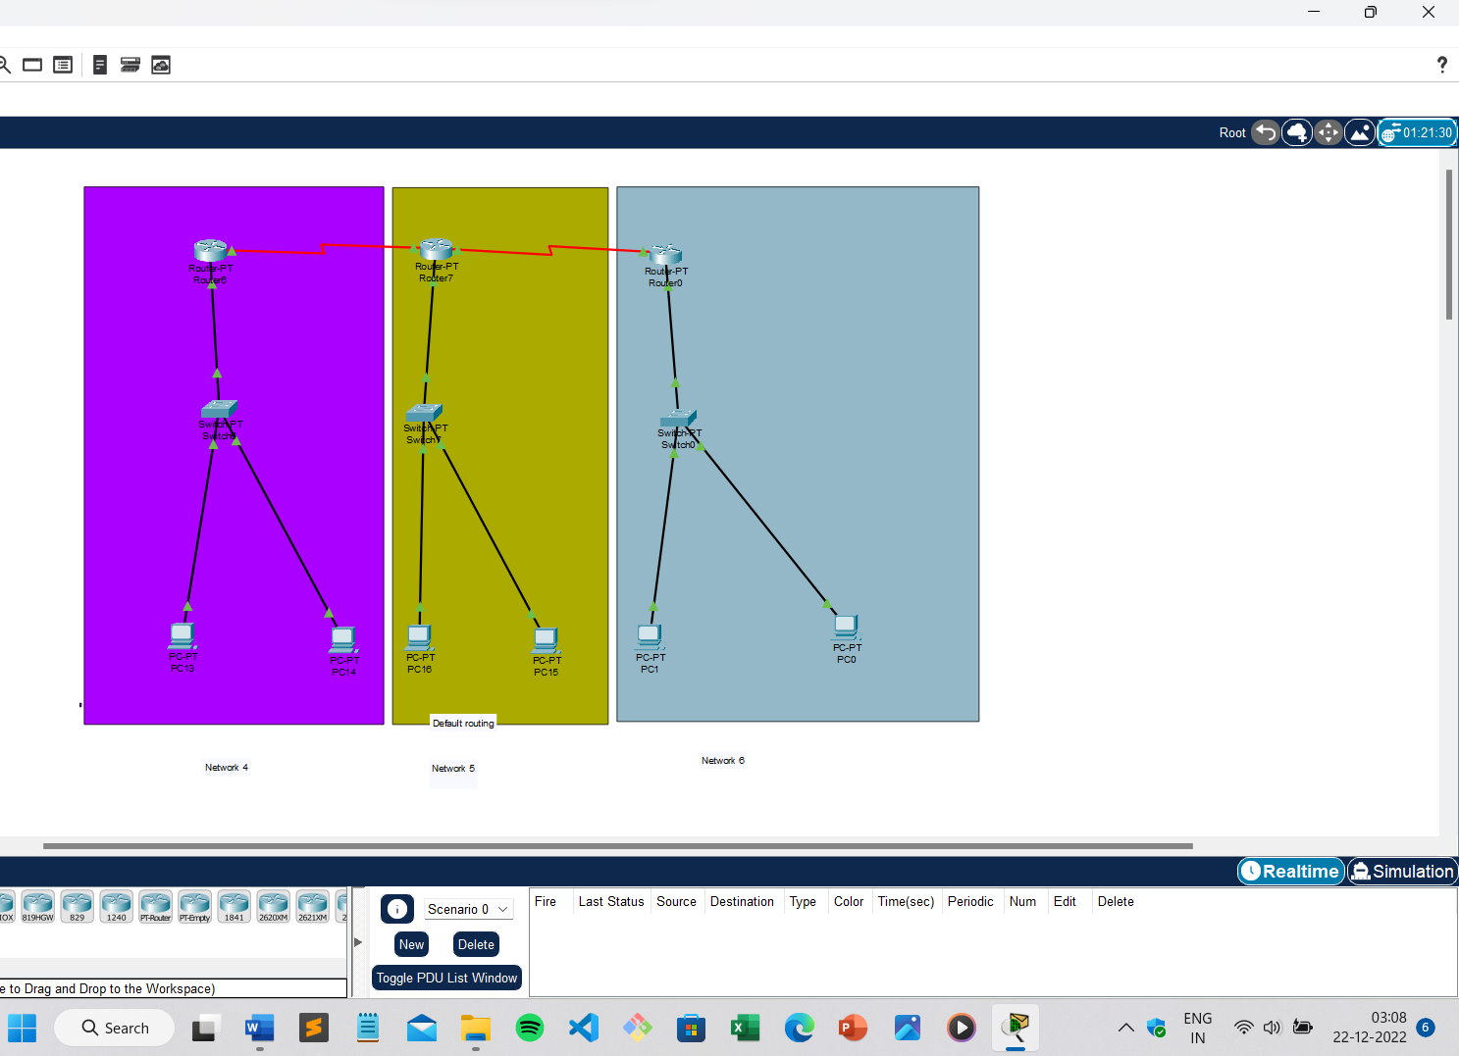

SUMMARY

There are mainly three types of routing. Static and Default Routing are two types of routing in which the path selection is controlled manually by a network administrator while dynamic routing paths are controlled by protocols automatically. And the main to find the best routing technique from both static and default routing

 References

1. [What is Static Routes and Default Routes | Difference between static and Default (snabaynetworking.com)](https://snabaynetworking.com/what-is-static-routes-and-default-routes-difference-between-static-and-default/)

2.<https://www.computernetworkingnotes.com/>

3. [Default Route in Cisco Routers - GeeksforGeeks](https://www.geeksforgeeks.org/default-route-in-cisco-routers/)